Native Stem Cells, Transplants Form Blood Differently

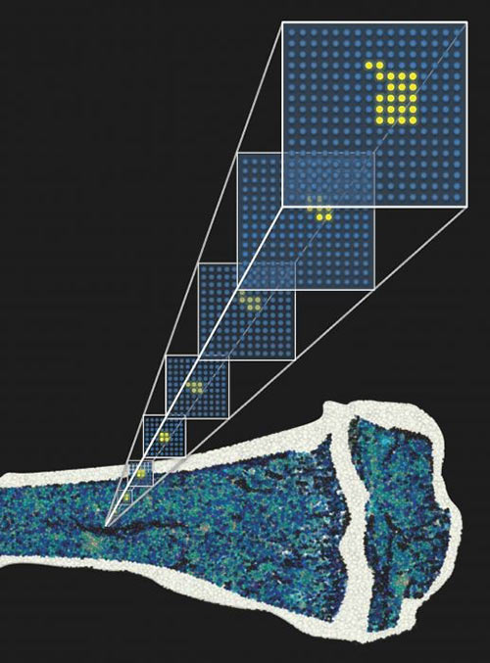 By following fluorescent labels that were passed from blood stem cells to daughter cells, scientists find that unperturbed hematopoiesis is highly polyclonal
- Blood cell formation, the process by which stem cells perpetuate streams of differentiated cells, is characterized by very different flows, depending on whether the ultimate font consists of transplanted stem cells or normal, unperturbed stem cells. Transplanted stem cells, it is well known, may give rise to all the cell types of the blood, even though very few of the transplanted stem cells—a tiny pool of long-term hematopoietic stem cells—sustain the upwelling. In normal hematopoiesis, by contrast, the springs are more numerous, the cascades more varied.
To study how stem cells mature into blood cells under normal conditions in a living organism, scientists at the German Cancer Research Center worked with genetically modified mice. The scientists engineered mice to ensure that the animals’ blood stem cells expressing the gene Tie2 could be genetically labelled with a fluorescent protein. Those cells and all their descendants would then fluoresce regardless of whether or not they expressed Tie2, allowing cell lineages to be traced.
When the scientists turned on the marker in adult animals, it revealed that about one third of a mouse's hematopoietic stem cells—approximately 5,000 cells—produce differentiated progenitor cells.
This result appeared February 11 in Nature, in an article entitled, “Fundamental properties of unperturbed hematopoiesis from stem cells in vivo.” The article also noted that the time to approach equilibrium between labeled hematopoietic stem cells and their progeny is surprisingly long—longer even than the mouse’s lifetime. To deal with this complication, the authors resorted to mathematical modeling in their analysis.
The analysis showed that, surprisingly, under normal conditions, the replenishment of blood cells is not accomplished by the stem cells themselves. Instead, they are actually supplied by first progenitor cells that develop during the following differentiation step. These cells are able to regenerate themselves for a long time, though not quite as long as stem cells do. To make sure that the population of this cell type never runs out, blood stem cells must occasionally produce a couple of new first progenitors.
During embryonic development of mice, however, the situation is different: To build up the system, all mature blood and immune cells develop much more rapidly and almost completely from stem cells.
The investigators were also able to accelerate this process in adult animals by artificially depleting their white blood cells. “In the adult mouse, 5-fluoruracil-induced leukopenia enhances the output of HSCs and of downstream compartments, thus accelerating hematopoietic flux,” wrote the investigators. “Label tracing also identifies a strong lineage bias in adult mice, with several-hundred-fold larger myeloid than lymphoid output, which is only marginally accentuated with age.”
In other words, blood stem cells increase the formation of first progenitor cells, which then immediately start supplying new, mature blood cells. In this process, several hundred times more cells of the so-called myeloid lineage (thrombocytes, erythrocytes, granulocytes, monocytes) form than long-lived lymphocytes (T cells, B cells, natural killer cells) do.
"When we transplanted our labeled blood stem cells from the bone marrow into other mice, only a few stem cells were active in the recipients, and many stem cells were lost," explained Professor Hans-Reimer Rodewald from the German Cancer Research Center. “Our new data therefore show that the findings obtained up until now using transplanted stem cells can surely not be reflective of normal hematopoiesis. On the contrary, transplantation is an exception [to the rule]. This shows how important it is that we actually follow hematopoiesis under normal conditions in a living organism.”
The authors of the Nature article concluded by noting that hematopoietic stem cell fate mapping and its linked modeling “provide a quantitative framework for studying in situ the regulation of hematopoiesis in health and disease.” The investigators plan to use their new model to investigate the impact of pathogenic challenges to blood formation. They anticipate that their method will also enable them to follow potential aging processes that occur in blood stem cells in detail as they occur naturally in a living organism.

